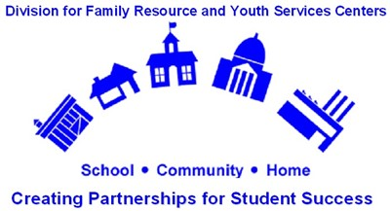

Welcome to FRYSC!
The primary goal of Family Resource and Youth Services Centers (FRYSC) is to remove non-cognitive barriers to learning as a means to enhance student academic success. Each center offers a unique blend of programs and services determined by the needs of the population being served, available resources, location and other local characteristics.
FRYSCs have established a record of success based on improved student performance in class work, homework and peer relations as reported by teachers. Parents, too, report they experience greater satisfaction and involvement with the schools as a result of assistance through the local FRYSC.

Hours of Operation
We are open daily from 8 a.m. until 3:00 p.m. We are in Caverna Elementary, Middle, & High Schools Monday through Friday. Evening and weekend hours are available by appointment only 270-773-4149.
We are located behind Caverna Elementary, with our home office being at Caverna Middle/High Schools. Our mailing address is 1106 North Dixie Hwy, Cave City KY. 42127. You may reach us at 270-773-4149 or -270-773-3229. If you wish to send a fax, 270-773-4668 .

FRYSC Mission Statement
In order to distinguish ourselves and set Caverna Family Resource Youth Service Centers apart from the rest, it is our responsibility to deliver, with enthusiasm and pride, a superior level of service each and every day.
This means providing accurate, responsive, courteous and value-added service in a caring, sincere, professional manner.
We will always try to exceed our families’, students’ and principals’ expectations, knowing that our families and students, as well as fellow employees depend on and trust us. We will come through for them with the quality service they deserve – the highest level of service – nothing less.
“Children are our most important investment, invest wisely.”
What does the Family Resource Youth Services Center do?
- Back to School - Readifest
- Open Houses/Back-to-School Bashes
- Child Abuse Awareness
- Counseling & Care
- Career Day – Elementary
- College and Career Fair – Middle/High Schools
- Mentoring Programs
- Referrals to Health & Social Service
- Reality Store
- Dollars & Sense
- Tutoring Programs
- Family Reading Nights
- Red Ribbon Week Activities/Events
- Substance abuse education and counseling
- Family crisis and mental health counseling
- Career exploration and development
- Summer and part-time job development for high school
- Canned Food Drive
- Thanksgiving Baskets for Needy Families
- Christmas Assistance
- Backpack program
- Community Closet

